**Multi-Layer Competitive Neural Networks for Image Classification**

*Artificial Neural Networks*

Danny Ly

Technical report

December 2017

**Abstract**

There exist many methods of pattern recognition with various performances index and technique, one technique however that is not very much explored is the use of Competitive Network in Artificial Neural Networks sub class. In this article we further explore implementation of the Competitive Neural network architecture and asses its performance to learn and recognize the MNIST hand written dataset. It turns out the learning vector quantization 2 learning rule works very well in pattern recognition, this network is able to achieve 96% accuracy with non-normalized input patterns. With the exploration of methods such as Data Driven Initialization, adaptive bias and dynamic learning rate this network was able to perform within competitive ranges.

# Introduction

The MNIST dataset consist of 60,000 various handwritten images, in a 28x28 pixel orientated vector space. This papers purpose is to discuss the researching findings of using an Artificial Neural network through training to recognize and help classify these images. The materials discussed in this document relate to University of Washington Artificial Neural network course. To explore further of how neural networks behave.

# The Task

The task to explore for this project is to understand the underlying mathematics as well as parameters and methods that can be applied to an artificial neural network to better help gain better classification performance. Aside from the main task, this project gives us a chance to further explore on our own the methodologies that were studied during the course work [1].

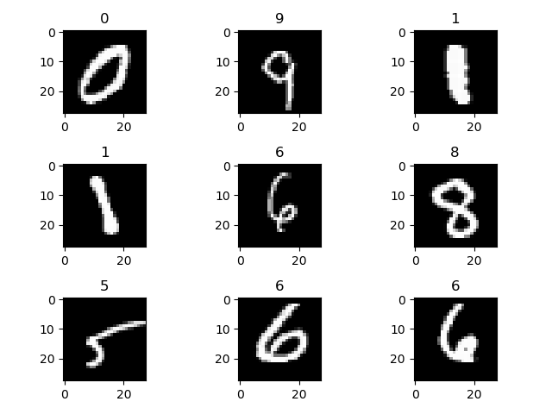

Figure Rendered digits

# Data Exploring

In this section we explore looking at the data in order to gain better insight on the problem at hand. The knowledge we would like to acquire from task are, what are the numbers of samples, what are the distribution of the data like? are there clustering ? Along with many methodologies that will allow us to help better choose our Artificial Neural network design.

## Statistics

Before starting this project, taking a look at the dataset that was given typically gives a good general idea of how to approach this problem. This knowledge that we use, can better help us decide what type of neural network architecture would be possible in order to solve the problem.

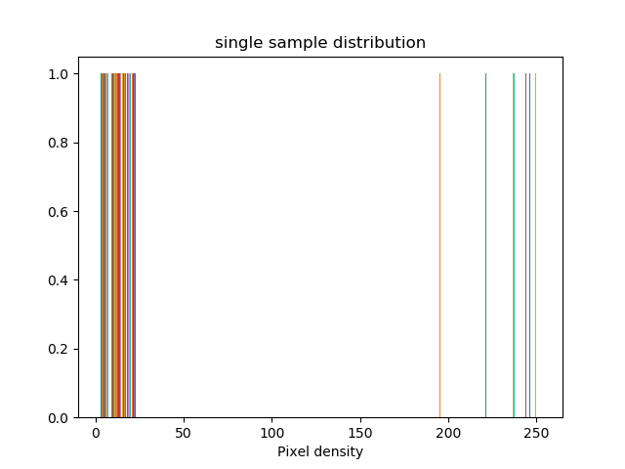

Figure Pixel Density for digit '5'

In the Above image I’ve plotted the distribution for a single sample, I did this instead of the entire dataset because, If we can understand a single sample and the problem. Each image is a vector in which each index holds a pixel density value between 0 and 255, calculating a mean in this case does not give us any more information of the entire population. Instead if we take a look at a single sample we can infer that each digit as we guess is of uniform distribution, meaning either a pixel will be of some gradient color or it will be black space. This tells us using method of normal distribution will not give us any more information about the dataset; not statistically significant.

## Dataset Distribution

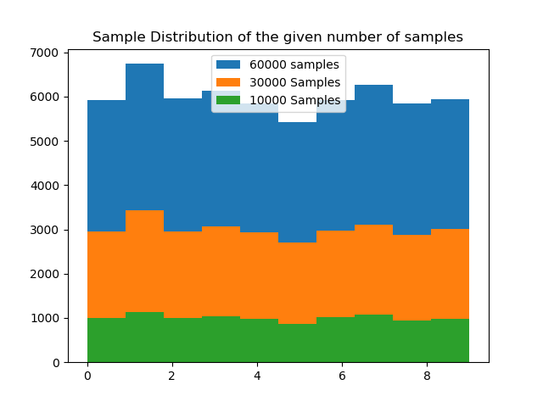

Figure Data Set Distribution

However here, we can start to think about the data, if there are 60,000 images, of this data we want to find out if there exist an even distribution of the sample. We do this because during training we do not want to introduce over dominate data to the network. If there were over dominate amounts of one observation over another we would therefore need to resample the population to get an even distribution. In our sample of 60,000 images, the above shows partitions of 10,000 and 30,000 as well. As we can see the distribution of the dataset is very even and normal, this tells us whether we train with 10 or 30 thousand samples there will be an even distribution of the data for our network in figure 3.

## PCA

In this section we know our initial problem is to classify the digits, we also gathered data on the distribution of the dataset, and the samples within the dataset. Although we have numbers of such at our dispersal, making a visual representation of the dataset since it is well normalized in sample size to see what we are working with through PCA will be considered. 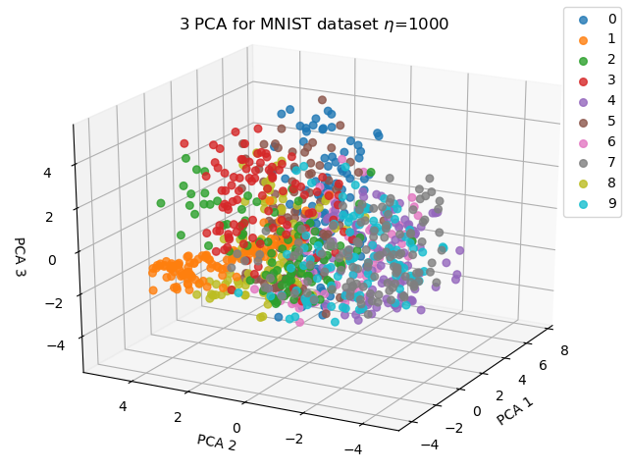

Figure PCA for 1,000 samples

Performing PCA we get three features whose Eigen values are the highest amongst its neighbors, which means these features contain the most variance explained. In figure 4, we can now visually express there are potential forms of clusters.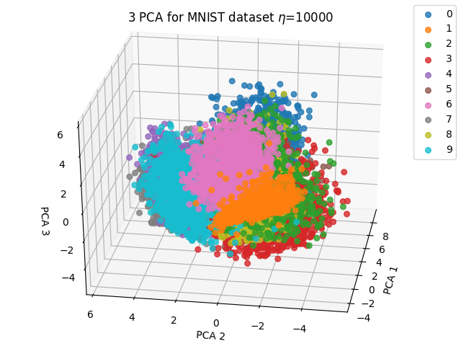

Figure PCA for 10,000 Samples

Here we take more samples to see the mass of data definitely forms clusters. This is important knowledge to know since we can design an architecture comfortably knowing there exist strong correlations between the digits and much cluster is available.

# Design

Knowing the data we’ve gathered about, we can see through PCA that this dataset contains dense clustering. The design I decided to implement for this project is a **Competitive Neural Network**. I choose this network because of its ability to place multiple subclasses of neurons within the input space and slowly move towards the masses of their assigned classes. The main reason for this is, the visual representation of our data we can see large masses of clusters which pushes me to Competitive Neural Network. Also to note in figure 6 we explain how the neurons are able to move towards these clusters by the competitive learning rule.

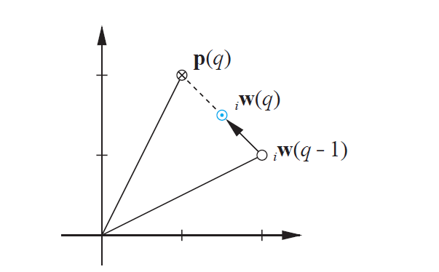

Figure Weights (q) moves closer to input p (q)

## Introduction

A Competitive Neural Network is a hybrid supervised learning network, this is because the first layer does not know the target outputs for the respective inputs until the second layer get the output from the first.

In a Competitive network the first layer exist of sub classes which are spread amongst the input vector spaces which are called prototype vector. When an input vector is introduced to the network each of these prototype vectors compete against one another, competition ends with whichever neuron’s prototype vector is closest to the input vector presented. Once the winning Neuron has been chosen its Weights will move closer to the input vector space defined by Kohonen learning rule:



Figure Kohonen Learning Rule

While there exist a few versions of this learning rule, that will be discussed further in methodologies.

## Architecture

For this networks design I went with a 2 layer network, the first network consist of a competitive layer and the second linear activation function.

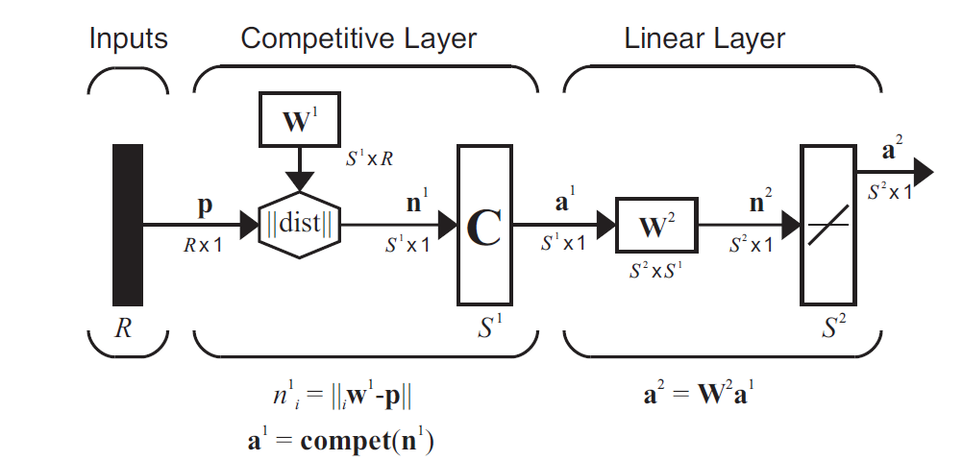

Figure [1] Architecture Design

In this design I used 150 neurons to form the subclasses in the competitive layer with 10 final neurons for the output layer. The second layer is necessarily since after each neuron in the first class has developed their individual prototype vectors there needs to be a way to combine all subclasses into their respective classes of the 10 digits. This is where the weights of the 2nd layer come in. The weights in the second layer combines the output of the first later into final classes, this is done through grouping each subclass neuron to their final output classes. For example in this design there exist 150 neuron in the first layer and 10 final neurons for the final layer. Dividing the final layer by the sub layers we have 10 neurons per class.

## Specifications:

= 150

R = 784

= 150 X 784

= -||||

= Compet ()

= 10 X

= X1

**Input:** 1X784 Vector *non-normalized*

**Competitive Transfer Function:** in the first layer the competitive transfer function works by looking for the largest Euclidean distance within each subclass, this distance explains how close a prototype vector is from the input vector

**Pure Linear Transfer Function:**  In the second layer the purlin function is used to combine all the neurons in the first layer to their respective class layers

**Arguments:**

* *Epochs : integer, default= 5*
* *Learning_rate : float, default=.1*
* *Verbose: Boolean, default = False*
* *DataDrivenInitalization: Boolean, default= True*
* *Conscience: Boolean, default = False*

# Methodologies

In this section I speak more in-depth s of my findings and design, as well as how I was able to solve them and any other methodologies that might have impacted my performance/ results. Here I layout each steps I took to design this network and within each step the things I discovered.

## Step 1 – Initial Layer 1 weights:

One of the most important aspect of this competitive network is that the initial prototype neurons in the first layer need to be dispersed within the input space, the few problems that arise in competitive neurons are neurons that do not cover the input space, where data lies, or neurons that are in input spaces where no data lie, these are considered *dead neurons.*

Initially for This design I decided to go with prototype vectors of uniform randomized picking. However I ran into problems where specific neurons were scattered within a cluster that were interfering with other neurons region and would be pushed away from where they needed to be.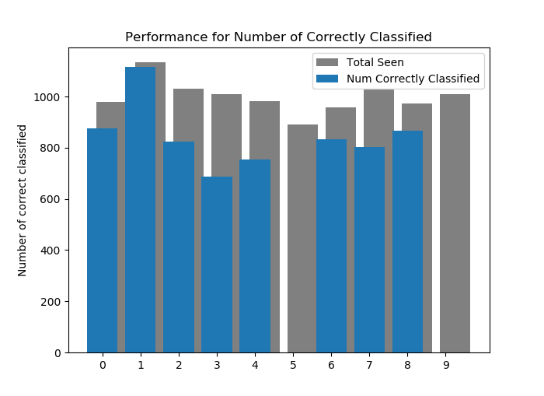

Figure Performance Of network with uniform weights

The result would be Neurons never being able to reach the input vectors they were assign to, as we can see from figure 8, the performance for this network did not recognize input vector 5 or 9. Upon further inspection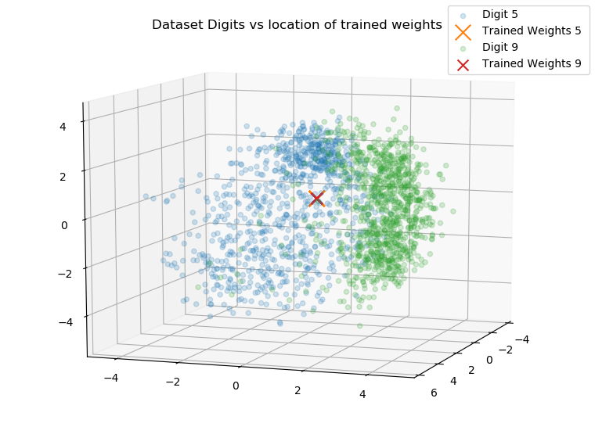

Figure 'Stacking' of initial Weights

As seen in figure 9, there are two neurons which are neurons in the cluster that belong to digit 9 and digit 5, as we can see the input space around the area between them, the problem here is the initialization of the random uniform weights put them dead in the center of these two classes, which meant when the competitive function looked for a winner these weights would oscillate between territories, therefore we have a stack of neurons in the center of the two input patterns.

To solve this issue there lies a method called Data Driven Initialization where each prototype neuron randomly chooses an input from the input vectors as their initial weights, this type of initialization allows each of the subclasses a better starting point to be within the range of their respective masses.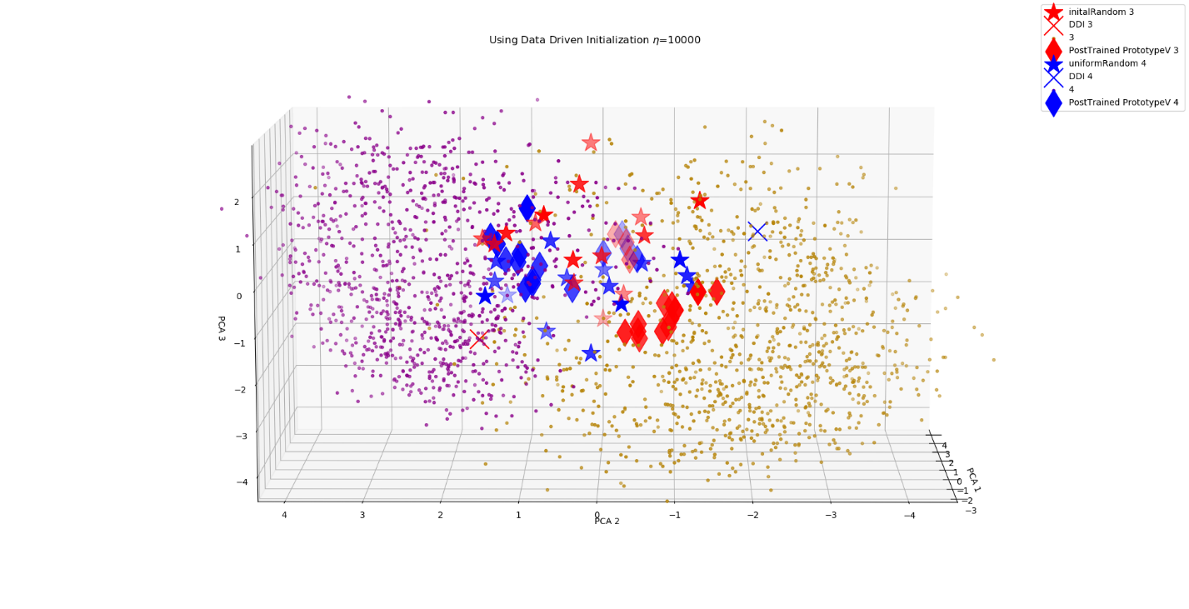

Figure Using Data Driven Initialization

As we can see above the ‘X’’s mark where a **single**  randomly selected input vector would be for a neuron’s initialized weights, the red ‘X’ on the bottom left corner represents the digit 3’s and the blue ‘X’ represented the digit 4. The Stars in the figure show the weights of random uniform picking. The important thing to notice here is that the single selected random data driven initialized weights are a lot more dispersed within their respective clusters, whereas the uniform random weights will likely cause a ‘stacking’ since both the initial weights invade territories of opposite classes.

To do a data driven initialization, randomly pick input vectors from the dataset.

## Step 2 – Layer 2 Weights

To select 2nd layer weights, we first must choose the number of neurons within the first layer, this is because the second layers weights is a union of the first layers target vectors, the problem I ran into here is for each input vector the target labels were a integer value. In order to convert those into 10x1 target vectors to match the final layers output of a^2 I used a method called *one-hot-encoding*  which allowed me to convert normal integers to unique vectors that represented them.

To find the orientation of the weights in the second layer use:

This means that for each class there exist a ‘neuron per group’ for that class, this is used to combine the neurons in the first layer to the final output layer. These groups are then stacked against each other to produce a place for each neuron in the first layer to classify to their respective classes in the second layer.

## Step 3 – Object Design:

After the weights have been selected, this design uses an array list to replicate holding of each layer, for each index exist a layer in the network for this network we use index 0, and 1. These indexes represent their respective layers, for each layer the array list holds a hash table with 3 key elements

1. ‘Weights’ : Neurons X input Vector size : matrix
2. ‘Transfunction’ : a respective Transfer function
3. ‘Bias’ : respective bias

When the network is first called, e initial the first and second layers, with a data driven initialization approach. After the network has been set up a call to the function train () takes 2 parameters an input matrix of the dataset and its respective target vector.

During training the network first takes the nth input vector and calculates the Euclidean distance between each prototype vector and the current input vector.

Once the winning Neuron is selected, we must check whether a classification was correctly made, if there was a correct classification then we update that winning neurons weights. However if there was a false positive winning neuron we must move this false positive neuron away from this input vector and move the second closest neuron towards the input vector.

## Step 4—Learning rate:

One of the most important hyper parameters of this network is the learning rate, because with a competitive layer the winning neuron moves closer to the input vector, however the learning rate is what decides the magnitude of this move.

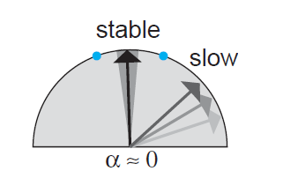

Figure [1] a low learning rate

As seen in figure 12. A low learning rate allows the network to converge between the masses in small steps, the down side to this is learning will be much slower since the prototype vectors must move to the respective locations.

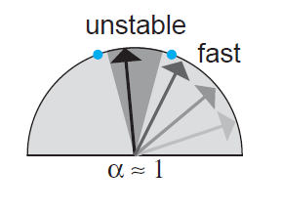

Figure [1] Fast Learning rate

However, a high learning rate will help learning faster but be quite unstable since the neuron will essentially jump between input vectors it is introduced to.

At first I approached this problem with trying to find a mean balance of an equilibrium of a learning rate that would fit a medium of low and high learning rate to grab both stable and fast learning. The results seen below in figure 14 show promise as the network slowly converges 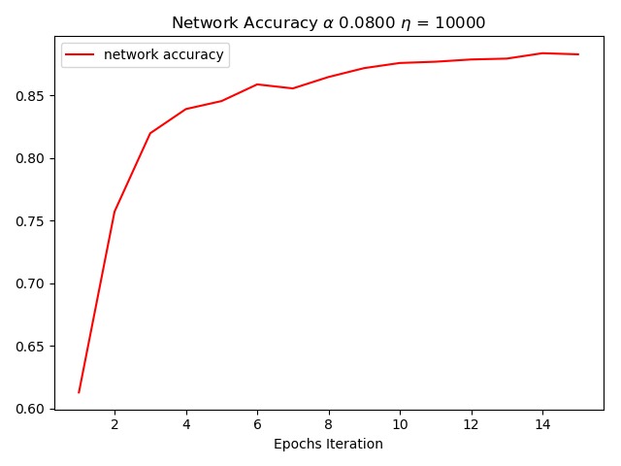

Figure Stable static Learning rate

In figure 14 shows a trained sample size of 30,000 and a static α = .08 for the accuracy we get about 91% correct classification

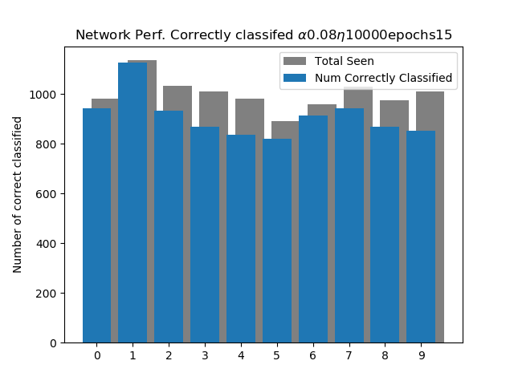

Figure Performance on test set

The respective Test set performance is showed in figure 15, as we can see given new data to the network, the network performs favorably. However over time of running multiple different configurations using more samples, less samples or a little bit more neurons in the hidden layer, the performance would always plateau at about 91% accuracy (.8% error)

This thinking behind this could be the culprit that was not being adjusted the **learning rate.** Understanding the network’s learning rule helped discover why the performance would plateau at about 90%, one favorable explanation was that the prototype vectors during training had converted to a location within the mass with a couple of input vectors that left out a few of the distorted inputs.

With this in mind, one way to test this theory was to implement a **dynamic learning rate**, here a dynamic learning rate is one that reads each iterations error, and compares it to the pervious performance. If the error is starting to decrease this tells us that the network is classifying correctly. The next step would be to check whether the performance is stabilizing or still shifting around.

If the network is slowly stabilizing we decrease out current learning rate. Decreasing the learning rate will help the neurons slowly converge to the center of mass which solves it moving to a specific location within the mass.

As the neuron’s learning rate is decrease so does its attraction to new input vectors not seen, this can be thought of as a way to ‘generalize’. If the error performance starts to increase we will shift out learning rate up , which can be thought of as , fixing the mistake we made last, since the last decrease in learning rate resulted in the lowest possible.

Implementing this dynamic learning rate proved to be hypothetically correct, since our results for the error now decreased in 4 % from 91% accuracy to 95% accuracy. In the below images we can see the following performance metrics of the networking using a dynamic learning rate, just as the static learning rate we can see the network have rough edges in the beginning however start to smoothen out towards the end. The explanation for this is in the beginning our learning rate is large so the network is able to jump around and capture the large mass it is attracted to, then as the error becomes smaller the learning rate is lowered such that new input vectors do not pull it around, which explains the smooth ending curve towards the end of training.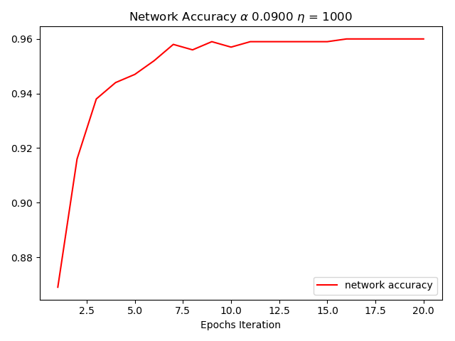

Figure Dynamic Learning Rate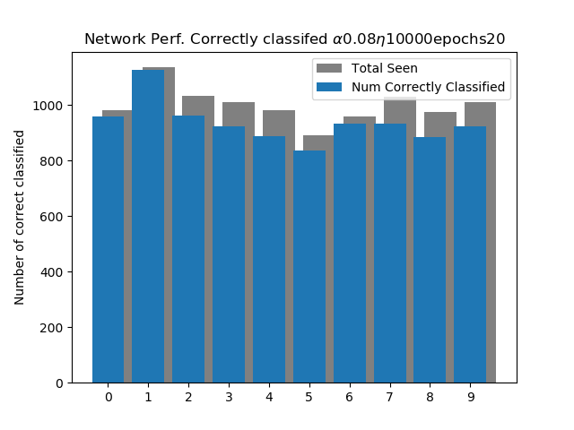

Figure Testing Set Dynamic Learning Rate

In Figure 17 we see the performance of the test set used on the trained network with a dynamic learning rate, although these shapes are quite similar to the static learning rate we can take a closer look and see that for digits 9 and 5 more of them clusters are being captured here with a dynamic learning rule.

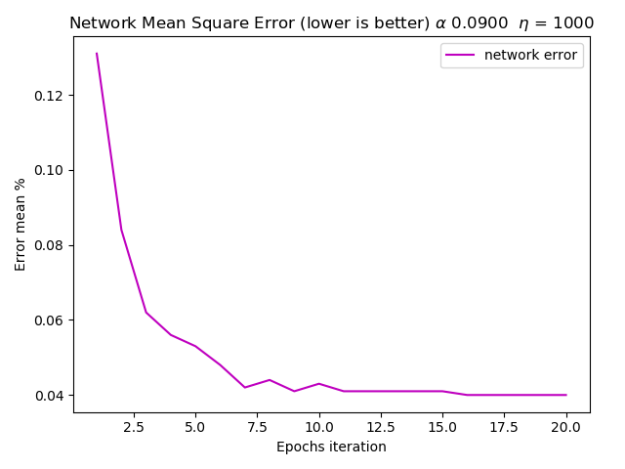

Figure Error of Dynamic Learning Rate

## Problems:

*Normalization -* After finishing the network, testing the network showed very poor performance, after closer inspection the Learning Vector Quantization works best when the input vectors are not normalized. This is also one of the advantages of using an LVQ neural network. The reason for an improved learning rate was because the when the input vectors were normalized the distances between the prototype vectors and input vectors were all clustered together, and would make it very difficult for neurons to migrate to where they needed to go.

*Adaptive bias –* ***‘****conscience’ s*  as the text states it is when we penalize all neurons when a winning neuron is chosen, this mixes’ all neurons whom have not had a chance to win to win, this is because the formula for implementing conscience is to multiply all neurons bias by .09 while subtracting -.02 to the winning neuron. However this does not implement well with a data driven Initialization of the weights, because we choose to initalize the weights by random input vectors each vector in theory should never be dead and within or near the mass of the input clusters. Which resulted in worst lower performance since we did not see any dead neurons, the root explanation for this was because of such low amount of neurons in the first competitive layer they did not have much neurons to compete with.

# Results

During this project, I saw how competitive networks real advantage of being able to use non normalized input vectors, although this feature would be dangerous for some large datasets, it allows the data to retain its original magnitude and scale.

I also learned about the way the competitive network is able to learn suing a dynamic vs static learning rate algorithm, which allows the network to capture groups of clusters better, using generalization. Aside from the performance I also learned about improves that could be done on this network such as improving the learning rule to implementing the learning vector quantization 2 learning rule, this allows 2 neurons to update when a false positive classification is made and a single winner-take all neuron to update if there is a correct classification.

In this network architecture I found 3D graphs where we perform Principle Component analysis the most useful since this network essentially moves neurons closer to their attractive clusters it helps to confirm what the network is actually doing by plotting the neurons position pre-trained vs post-trained.

Conclusion:

During this project I learned that a competitive neural network performs best on data that are non-linear, in example just as the MNIST data set, the distribution was uniform, and there were no(few) linear relationship between each input vector. This is because this competitive network tries to build relationships to the center of the mass of clustered data. If there were relations between each dataset the clusters would cause the performance to suffer because neurons would have a hard time crossing through thin regions of other neurons classification zone.

I also learned for this learning algorithm it is best to use a data driven initialization approach to avoid randomly selecting prototype weights that are nowhere near the mass of input vectors to be learned from.o

o

Extras:

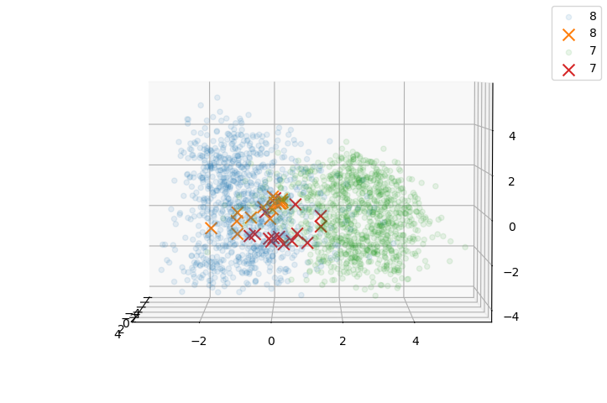

Figure Post Trained Prototype Vectors

In figure 19 we confirm that the competitive network is doing what it should, as we can see the clustering of neurons belonging to digit 8 and 9 group towards their correct digit cluster.

Here we can see that the weights although are still close, have a solid respective separation between the two cluster masses, this is a good sign since our training just introduced 25000 input data on 12 epoch that hypothesis is more training with a dynamic decaying learning rate will give us better results.

The learning rate is very sensitive



Ideas: implement a dynamic adjusting learning rate, when the error rate seems to be going high or stabilizing we will start to decay the learning rate, however if the network still have an error rate lets step up the learning rate

Appendix:

Implementation of code

#=#=#=#=#=#=#=#=#=#=#=#=#=#=#=#=#=#=#=#=#=#=#=#=#=#=#=#=#=#=#=#=#=#=#=#=#=#=#=#=#=#=#=#=#=#\|  
#=#| Author: Danny Ly MugenKlaus RedKlouds  
#=#| File: CompetitiveNetwork.py  
#=#| Date: 12/6/2017  
#=#|  
#=#| Program Desc:  
#=#|  
#=#| Usage:  
#=#|  
#=#=#=#=#=#=#=#=#=#=#=#=#=#=#=#=#=#=#=#=#=#=#=#=#=#=#=#=#=#=#=#=#=#=#=#=#=#=#=#=#=#=#=#=#=#\|  
  
*from* mnist *import* MNIST  
*import* numpy *as* np  
*import* pickle, os, random  
*from* matplotlib *import* pyplot *as* plt  
*from* neurolab.trans *import* PureLin  
  
np.random.seed(5)  
  
  
*class* Network:  
 *def* __init__(self, *epoch*=5, *learning_rate*=.1, *verbose*=*False*, *dataDrivenInitalization*=*True*, *conscience*=*False*):  
 """  
  
 This is a competitive Artificial Neural Network  
 using the Learning Vector Quantization method  
 Discovered by Kohonen  
 Default constructor  
 """  
  
 #Testing is 50 subclasses, and 10 final classes  
 # with input as a 1 X 784 input vector  
 self.classes = 10  
 self.subclasses = 300  
 self.inputVectorSize = 784  
 self.useDDI = *dataDrivenInitalization* self.conscience = *conscience* self.layers = [] # each index is a layer  
 self.learning_rate = *learning_rate* # the learning rate of the network  
 self.epoch = *epoch* # number of training iterations  
  
 self._setUpNetwork()  
  
 self.error_results = list()  
  
 self.epoch_error = []  
 self.epoch_accuracy = []  
  
 self.makeFinalClassLayer(self.classes, self.subclasses)  
  
 *def* _dataDrivenInitalization(self, *subclasses*, *classes*, *imageVector*, *labelVector*):  
  
 *assert subclasses* % *classes* == 0  
 neuronsPerClass = int(*subclasses* / *classes*)  
 # each neuron in the group should be a random input vector of the input  
  
 data_X = np.matrix(*imageVector*)  
 data_Y = np.array(*labelVector*)  
  
 #make a default zero matrix to manipulate  
 d = np.matrix(np.zeros((*subclasses*, self.inputVectorSize)))  
  
 # for the rows 0 -> 4 should be 0 digit 0  
 digit = 0  
 *for* i *in* range(0, *subclasses*, neuronsPerClass):  
 ve = data_X[data_Y == digit]  
 *for* j *in* range(i, i + neuronsPerClass):  
 ridx = random.randint(0, len(ve)-1)  
 d[j, :] = ve[ridx]  
 digit += 1  
 print(d.shape)  
 print(d.T.shape)  
 *assert* d.shape == (self.subclasses,self.inputVectorSize)  
  
  
  
 self.deadDetection = d.copy()  
 ff = open("detectDead.p",'wb')  
 pickle.dump(self.deadDetection,ff)  
 ff.close()  
  
  
 self.layers[0]['weights'] = d.T  
  
 print("finished Data Driven Initialization")  
 *def* _getHotEncoding(self, *targetInteger*):  
 """  
 One hot encoding returns a one got encoded value to the  
 respective target Integer  
 :param targetInteger: ex 5 will return a 1x10  
 ie: 5 -> [0,0,0,0,0,1,0,0,0,0,0]  
 :return: returns a numpy matrix  
 """  
 _hot_encoding = np.matrix([  
 [1, 0, 0, 0, 0, 0, 0, 0, 0, 0],  
 [0, 1, 0, 0, 0, 0, 0, 0, 0, 0],  
 [0, 0, 1, 0, 0, 0, 0, 0, 0, 0],  
 [0, 0, 0, 1, 0, 0, 0, 0, 0, 0],  
 [0, 0, 0, 0, 1, 0, 0, 0, 0, 0],  
 [0, 0, 0, 0, 0, 1, 0, 0, 0, 0],  
 [0, 0, 0, 0, 0, 0, 1, 0, 0, 0],  
 [0, 0, 0, 0, 0, 0, 0, 1, 0, 0],  
 [0, 0, 0, 0, 0, 0, 0, 0, 1, 0],  
 [0, 0, 0, 0, 0, 0, 0, 0, 0, 1]])  
 *return* _hot_encoding[*targetInteger*]  
  
 *def* makeFinalClassLayer(self, *numClasses*, *numSubClasses*):  
 """  
 For the final output layer we need a layer to combine all subclasses from the pervious layers to our  
 final layer, therefore this method will create a one-hot encoding final layer for the number of classes/categories  
 of the problem we are trying to solve.  
 :return:  
 """  
 *assert numSubClasses* % *numClasses* == 0, "Error there is an unbalanced subclass count please recheck your settings"  
 # make the one hot encoded matrix  
 hot_encode = np.zeros(shape=(*numClasses*, *numClasses*))  
  
 *for* i *in* range(len(hot_encode)):  
 hot_encode[i][i] = 1  
 # we know that we have 0 - 9 digits  
 # this hot_encode hold for each index a unique value  
 # each index is also associated with each digit starting from 0 -> 9  
  
 subclassPerClass = *numSubClasses* / *numClasses* # get the number of sub classes per class in final layer  
  
 # assign groups of subclasses to classes  
 hot = 0  
 m = np.matrix(np.zeros(shape=(*numClasses*, *numSubClasses*))) # make a default subclass  
  
  
 *for* i *in* range(*numSubClasses*):  
 # m.append(hot_encode[hot])  
 *if not* i == 0 *and* i % subclassPerClass == 0:  
 hot += 1  
  
 m[:, i] = np.matrix(hot_encode[hot]).T  
  
 *assert* m.shape == (self.classes, self.subclasses)  
 *return* m  
  
 *def* _competitiveTrans(self, *data*):  
 r = np.zeros_like(*data*)  
 max = np.argmax(*data*) # get the index with the maximum value  
 r[max] = 1.0  
 *return* r # returns the maximum value the winning neurons index  
 *def* _prelinTrans(self, *data*):  
 p = PureLin()  
 *return* p(*data*)  
 *def* _setUpNetwork(self):  
 """  
 Our input is a 28 X 28 single row vector, so 784 rows  
 Set up a the networks layers,  
 generate random weights and bias for the given number of neurons  
 :return:  
 """  
  
 # so initially we want 50 subclasses so 50 neurons amongst 784 features  
  
 # s is 50 R is 784  
 #np.random.seed(0)  
 W_1_0 = np.matrix(np.random.uniform(low=0, high=1, size=(  
 self.subclasses, self.inputVectorSize))) # 50 X 784#the input areas normalized between 0 and 255 or 0,1  
  
 #self.deadDetection = W_1_0.copy()  
 print( W_1_0.shape)  
 print( W_1_0.T.shape)  
  
 *assert* W_1_0.shape == (  
 self.subclasses, self.inputVectorSize), "Error initializing weights " # assert check that these parameters or checkpoints are forced.  
  
  
 B_1_0 = np.matrix(np.random.uniform(0,.5, (1,self.subclasses)))  
 *assert* B_1_0.shape == (1,self.subclasses)  
 layer1 = {'weights': W_1_0.T, # per following the equations Transpose such that each colum is a nueron  
 'transFunc': 'Compet',  
 'bias': B_1_0.T}  
  
  
 W_2_0 = self.makeFinalClassLayer(self.classes, self.subclasses)  
  
 *assert* W_2_0.shape == (self.classes, self.subclasses)  
  
 layer2 = {'weights': W_2_0,  
 'transFunc': 'Purlin',  
 'bias': 0}  
  
 # populate the layers  
 self.layers.append(layer1)  
 self.layers.append(layer2)  
  
 *def* train(self, *inputVectors*, *targetVectors*):  
 """  
 pulbic function to train the network  
 :param inputVectors: Given a input matrix  
 :parem targetVectors: Given a inputVectors  
 :return: None, Network has been trained  
 """  
  
 self.numSamples = len(*inputVectors*)  
 *if* self.useDDI:  
 self._dataDrivenInitalization(self.subclasses,self.classes,*inputVectors*,*targetVectors*)  
  
  
 decay_rate = 10  
 *for* iter *in* range(self.epoch): # for each epoch  
 c_e = 0 # initialize the current error for this epoch  
 *for* pInput *in* range(len(*inputVectors*)):  
  
 # Normalize the input vector by 255.0 ( normalize the input )  
 #_P = np.matrix( np.divide(inputVectors[pInput], 255.0) )  
  
 _P = np.matrix(*inputVectors*[pInput])  
  
 # _P = (_P - _P.min())/ (_P.max() - _P.min())  
  
 *assert* _P.shape == (1, self.inputVectorSize), "Input vector dimensions error"  
  
 # get the target integer of the respective input  
 targetIndex = *targetVectors*[pInput]  
 # get the one-hot-encoded vector of the respective target input integer  
 _T = self._getHotEncoding(targetIndex).T  
  
 # right now we exact Weights to be 50X784  
 *assert* self.layers[0]['weights'].shape == (self.inputVectorSize, self.subclasses), "Weights are correct dimensions"  
  
 # calculate the net input of the first competitive layer  
 # using Euclidean distance of two vectors  
 # -|| dist ||  
 netInput_1 = -abs(np.matrix(np.linalg.norm(self.layers[0]['weights'].T - _P ,  
 axis=1)))  
  
  
  
 netInput_1 = netInput_1.T # transpose the results  
  
 ## conscience  
 *if* self.conscience:  
 netInput_1 = netInput_1 + self.layers[0]['bias']  
 ###########  
 # calculate the output of the first layer  
 a_1 = self._competitiveTrans(netInput_1)  
  
 #################### second layer ######################  
  
  
  
 *assert* self.layers[1]['weights'].shape == (self.classes, self.subclasses), "Error with layer 2 weights"  
  
 *assert* a_1.shape == (self.subclasses, 1), "First layer shape failed"  
  
 # net input of the second purline layer w^2 * a^1  
 # this combines all subclasses to the respective classes in the output layer  
 netInput_2 = np.dot(self.layers[1]['weights'], a_1)  
  
 *assert* netInput_2.shape == (self.classes, 1), "net input 2 failed shape"  
  
 # calculate the output of the second layer,  
 a_2 = self._prelinTrans(netInput_2) # stand them up #10X 1  
  
 # tells us which class this input belongs too  
  
 *assert* _T.shape == (self.classes, 1), "Error with Target vector"  
  
 # calculate the error  
  
 mse = (np.square(_T - a_2)).mean()  
  
  
  
 ########### update weights ###########  
  
 # get the potentially winning neuron  
  
 winning_neuron = np.argmax(a_1)  
  
 # deep copy the net input to modified  
 Copy_N = netInput_1.copy()  
 # now set the first winning to -inf  
 Copy_N[winning_neuron] = -np.inf  
  
  
 runner_up = np.argmax(Copy_N) # Get the second winner up from the copied net input  
  
 correct = np.array_equal(_T, a_2)  
 *assert* self.layers[0]['weights'].shape == (self.inputVectorSize, self.subclasses), "ERROR with updaing weights"  
  
 #if mse == 0.0:  
 *if* correct:  
 c_e += 1  
 # correctly classified  
 self._updateWeights(_P, winning_neuron)  
 *else*:  
 # false positive, update the runner up  
 self._updateWeights(_P, winning_neuron, runner_up)  
  
  
  
 *if* iter > 1:  
 #we have at least 2 iterations  
 # check if the error is within a specific distance  
 improv = self.epoch_error[iter - 1] - round((1 - (c_e / len(*inputVectors*))), 7)  
 print("Current improvment %s" % improv)  
 *if* improv > 0.06:  
 self.learning_rate = round(self.learning_rate - .006, 4)  
 print("decreasing LR %s" % self.learning_rate)  
 *elif* improv < 0.0006:  
 self.learning_rate = round( self.learning_rate + .002, 4)  
 print("Increasing LR %s " % self.learning_rate)  
  
 self.epoch_error.append(round(1 - (c_e / len(*inputVectors*)), 7))  
 self.epoch_accuracy.append(round((c_e / len(*inputVectors*)),7))  
  
  
 print("ERROR FOR epoch: %s | Current Error Rate: %s | Numbers Correctly Classified: %s | Total Patterns seen %s" % (  
 iter, self.epoch_error[iter], c_e, len(*inputVectors*)))  
 ################################### WEIGHT UPDATE ########################################  
  
 *def* _updateWeights(self, *inputVector*, *winningNeuron*, *runnerup*=*None*):  
 """  
 If you give me a runner up that means that there is a WRONG classification  
 :param winningNeuron: Int of the winning or false winning neron  
 :param runnerup: the runner up if we have a false positive  
 :return: None, Weights 2 neurons will be updated if false positive, else single neuron is updated.  
 """  
 moveCloser = *winningNeuron* # default  
 *if runnerup is not None*:  
 # we had a wrong classification move this neuron closer , which is the runner up neron  
 moveCloser = *runnerup* # move the false positive neuron away  
 self.layers[0]['weights'][:, *winningNeuron*] = self.layers[0]['weights'][:, *winningNeuron*] - (  
 self.learning_rate * (*inputVector*.T - self.layers[0]['weights'][:, *winningNeuron*]))  
  
 # move Closer adjust if we have a runner up then move closer i the runner up if we do not we default the moveCloser as winning neuron  
 # move the runner up closer and the winner farter, we always move something closer  
 self.layers[0]['weights'][:, moveCloser] = self.layers[0]['weights'][:, moveCloser] + (  
 self.learning_rate * (*inputVector*.T - self.layers[0]['weights'][:, moveCloser]))  
  
 #######################  
 # conscience  
 # winning neuron gets its bias reduced while all others are multiplied by a scalar  
  
 #save the bias for the old bias  
 *if* self.conscience:  
 hold = self.layers[0]['bias'][moveCloser]  
 fill = np.full((self.subclasses,1),.9)  
 #multiply all bias by this scaler  
 self.layers[0]['bias'] = np.multiply(self.layers[0]['bias'],fill)  
 # penalize the winning neuron  
 self.layers[0]['bias'][moveCloser] = hold - .2  
  
 *def* findDeadNeuron(self):  
 #weights currently are col are neurons  
 count = 0  
 *for* i *in* range(self.subclasses):  
 *if* np.array_equal(self.deadDetection.T[:,i], self.layers[0]['weights'][:,i]):  
 count +=1  
 *return* count  
 *def* plotPerformance(self):  
  
 ff = plt.figure(8)  
 print("Error: %s" % self.epoch_error)  
 print("Accuracy: %s " % self.epoch_accuracy)  
 print("Number of dead Nurons %s" % self.findDeadNeuron())  
 x = np.arange(1, self.epoch + 1)  
  
  
  
 plt.title(r"Network Mean Square Error (lower is better) $\alpha$ %.4f $\eta$ = %s" % (  
 self.learning_rate, self.numSamples))  
 plt.plot(x, self.epoch_error, color='m', label="network error")  
 plt.xlabel("Epochs iteration")  
 plt.ylabel("Error mean %")  
 plt.tight_layout()  
 plt.legend()  
 fff = plt.figure(23)  
 plt.title(r"Network Accuracy $\alpha$ %.4f $\eta$ = %s" % (self.learning_rate, self.numSamples))  
 plt.xlabel("Epochs Iteration")  
 plt.plot(x, self.epoch_accuracy, color='r', label="network accuracy")  
 plt.legend()  
  
 plt.tight_layout()  
 plt.show()  
  
 *def* predict(self, *inputVector*, *targetVector*):  
 """  
 Test the network's performance to perdict what the given handwritten vector is  
 :param inputVector:  
 :param targetVector:  
 :return:  
 """  
 _t = np.matrix(self._getHotEncoding(*targetVector*)).T # returns the target   
 _p = np.matrix(*inputVector*)  
 *assert* _p.shape == (1, self.inputVectorSize)  
 *assert* self.layers[0]['weights'].shape == (self.inputVectorSize, self.subclasses)  
 *assert* _t.shape == (self.classes, 1)  
 n_1 = -abs(np.matrix((np.linalg.norm(self.layers[0]['weights'].T - _p, axis=1))))  
 a_1 = self._competitiveTrans(n_1.T)  
 *assert* a_1.shape == (self.subclasses, 1)  
  
 # second layer  
 *assert* self.layers[1]['weights'].shape == (self.classes, self.subclasses)  
 n_2 = np.dot(self.layers[1]['weights'], a_1)  
 *assert* n_2.shape == (self.classes, 1)  
 pur = PureLin()  
 a_2 = pur(n_2) # stand them up # 10 X 1  
 *assert* a_2.shape == (self.classes, 1)  
  
 *return* np.array_equal(_t, a_2)  
 *def* savePrototypeWeights(self):  
 """  
 Analytics save the current trained prototypes to a file to analyze  
 :return:  
 """  
  
 *import* pickle  
 f = open("NetworkWeights.pick",'wb')  
 pickle.dump(self.layers[0]['weights'].T, f)  
 f.close()  
  
  
*def* pickleData():  
 # pickle the data  
 # faster load times  
 mndata = MNIST('./data')  
  
 images, labels = mndata.load_training() # loads only the training data  
 ################################  
 # pickle the data  
 imageFile = open('./Sources/images.pickle', 'wb')  
 pickle.dump(images, imageFile)  
 labelsFile = open('./Sources/labels.pickle', 'wb')  
 pickle.dump(labels, labelsFile)  
 imageFile.close()  
 labelsFile.close()  
  
 ################## Testing  
  
  
 # images, labels = mndata.load_training()# loads only the training data  
 images, labels = mndata.load_testing()  
 imageFile = open('./Sources/images_Test.pickle', 'wb')  
 pickle.dump(images, imageFile)  
 labelsFile = open('./Sources/labels_Test.pickle', 'wb')  
 pickle.dump(labels, labelsFile)  
  
 imageFile.close()  
 labelsFile.close()  
 #############################  
  
  
*def* loadPickleData():  
 imageVFile = open('./Sources/images.pickle', 'rb')  
 imageVector = pickle.load(imageVFile)  
 imageLFile = open('./Sources/labels.pickle', 'rb')  
 labelVector = pickle.load(imageLFile)  
  
 imageVFile.close()  
 imageLFile.close()  
  
 imageVFile_Test = open('./Sources/images_Test.pickle', 'rb')  
 imageVector_Test = pickle.load(imageVFile_Test)  
 imageLFile_Test = open('./Sources/labels_Test.pickle', 'rb')  
 labelVector_Test = pickle.load(imageLFile_Test)  
  
 imageVFile_Test.close()  
 imageLFile_Test.close()  
  
 *return* imageVector, labelVector, imageVector_Test, labelVector_Test  
  
  
*def* generateImageVector(*imageV*, *labelV*):  
 fig = plt.figure(1)  
 *for* i *in* range(1, 10):  
 plt.subplot(3, 3, i) # 3 rows 3 columns, and subplot number starting at 1  
 randomImage = random.randint(0, len(*imageV*))  
 pixels = np.array(*imageV*[randomImage]) # pick a random image vector to display  
 pixels = pixels.reshape((28, 28)) # reshape the single row vector 784 X 1 to a square matrix  
 plt.imshow(pixels, cmap='gray') # put the image on the subplot  
 plt.title(*labelV*[randomImage]) # show the label of the image, using the image vector  
 plt.tight_layout() # prevent label overlays  
  
  
*def* loadData():  
 # check if the picked files exist, load them if so, else make them  
 *if* os.path.isfile('./Sources/images.pickle') \  
 *and* os.path.isfile('./Sources/labels.pickle'):  
 imagesVector, labelsVector, imageV_test, lablV_test = loadPickleData()  
 print("file exist")  
 *return* imagesVector, labelsVector, imageV_test, lablV_test  
 *else*:  
 pickleData()  
 print("does not exist")  
  
  
*def* testLVQNetwork(*numSamples*, *learningRate*,*epochs*):  
 # make an instances of LVQNetwork  
 # take the testing data,  
 # run the test using the 'predict  
 # function to test the network against what it gives and what wee expect  
  
  
 imagesVector, labelsVector, imageVector_Test, labelsVector_Test = loadData() # load the data  
  
 generateImageVector(imageVector_Test, labelsVector_Test)  
  
 f = open('./saveNetwork.pickle', 'rb')  
  
 network = pickle.load(f)  
 f.close()  
  
 results = dict()  
 # initalize dict  
 *for* i *in* range(10):  
 # 0,...,9 inclusive  
 results[i] = {'testCount': 0,  
 'correctCount': 0,  
 'classifiedErrors': list()}  
  
 *for* pattern *in* range(len(imageVector_Test)):  
 # for each testing pattern's index  
 result = network.predict(imageVector_Test[pattern], labelsVector_Test[pattern])  
 # true if they are classified correctly false otherwise  
 *if* result == *True*:  
 # corectly classified  
 results[labelsVector_Test[pattern]]['correctCount'] += 1 # increment  
 *else*:  
 results[labelsVector_Test[pattern]]['classifiedErrors'].append(labelsVector_Test[  
 pattern]) # record the patterns that were miss classified maybe get some insight on what’s going on  
 results[labelsVector_Test[pattern]]['testCount'] += 1 # increment number of times we've tested this pattern  
 # print(result)  
 print("TOTAL TEST: %s" % len(imageVector_Test))  
 # print the results in a  
  
 x = np.arange(0, 10)  
 y = list()  
 y_total = list()  
 *for* i *in* sorted(results):  
 y.append(results[i]['correctCount'])  
 y_total.append(results[i]['testCount'])  
 # print(y)  
 print(results)  
  
 ff = plt.figure(6969)  
  
 plt.bar(x + .25, y_total, label="Total Seen", color='gray')  
 plt.bar(x, y, label="Num Correctly Classified")  
 # plt.subplot(1,1,1)  
  
 plt.xticks(x, ('0', '1', '2', '3', '4', '5', '6', '7', '8', '9'))  
 plt.ylabel("Number of correct classified")  
 # plt.xlabel("Digit")  
 plt.title(r"Network Perf. Correctly classifed $\alpha$%.2f$\eta$%sepochs%s" % (*learningRate*,*numSamples*,*epochs*))  
 plt.legend()  
  
 plt.show()  
  
  
  
  
  
  
  
  
*def* main():  
 TRAINING = *False* #ep = 15  
 ep = 20  
 lr = .08  
 #lr = 7  
 ns = 10000  
 *if* TRAINING:  
  
  
  
 imagesVector, labelsVector, imageVector_Test, labelsVector_Test = loadData() # load the data  
 net = Network(epoch = ep, learning_rate = lr, dataDrivenInitalization = *True*)  
 # small learning rate .006 made 9 impossible to find  
 num_samples = ns  
 net.train(imagesVector[0:num_samples], labelsVector[0:num_samples])  
  
  
 # save the state of the network for testing  
 f = open('./saveNetwork.pickle', 'wb')  
 pickle.dump(net, f)  
 f.close()  
  
 net.savePrototypeWeights()  
  
  
 net.findDeadNeuron()  
 net.predict(imagesVector[3000], labelsVector[3000])  
 net.plotPerformance()  
 *else*:  
  
 testLVQNetwork(ns,lr,ep)  
  
  
*if* __name__ == "__main__":  
 main()

Acknowledgment

<https://stackoverflow.com/questions/40427435/extract-images-from-idx3-ubyte-file-or-gzip-via-python> :directions to parse the mnist data file

<https://github.com/sorki/python-mnist/blob/master/mnist/loader.py> : python-mnist loader, replace . with – since in his code, that’s the syntax

<https://stackoverflow.com/questions/17682216/scatter-plot-and-color-mapping-in-python> : color mapping in matplotlib

<http://www.apnorton.com/blog/2016/12/19/Visualizing-Multidimensional-Data-in-Python/> : data visualizations in python

<https://matplotlib.org/tutorials/intermediate/tight_layout_guide.html> : plotting guide

<http://alexanderfabisch.github.io/t-sne-in-scikit-learn.html> : TSNE

[1] Neural Network Design 2nd. Edition Martin TR. Hagen